**Classroom Activity​- Write a program to iterates over numbers from 1 to 10 and prints only the even numbers, skipping the odd numbers using continue.**

**Code-**

for (let i = 1; i <= 10; i++) {

// If the number is odd, skip the rest of the loop and continue with the next iteration

if (i % 2 !== 0) {

continue;

}

console.log(i); // This will only print even numbers

}

**Output-**

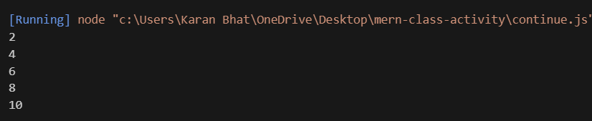

**Execution-Steps:**

* Create a JavaScript file with any name
* Write the code
* Run the code in the terminal using F5 or right click and go to inspect and you can get the output in the console as well.